
Faculty of Science

Course: CSCI 2020u – Software System Development & Integration
Component: Assignment
Weight: 10%
Deadline: March 5, 2020 (due by 11:59pm)

Collaboration Policy
You are permitted to work on this assignment in a team, and submit the results as a team. For this sort of assignment, with an open-ended component, the collaboration between multiple team members can be beneficial. Between groups, however, please limit the discussion to the level of general strategy (not code). Groups of size 2 are recommended. Larger groups will be considered with the proviso that the marker will mark your assignment with higher expectations. In any case, be sure that all members of the team fully understand all code, otherwise they will miss intended learning objectives, which may be a considerable disadvantage at exam time.

How to Submit
You will maintain a git repository for this assignment, which is a public repository. To submit the assignment, create a single file ‘README.txt’ that contains instructions on how to download, compile, and run your codes for each question. A .zip, .7z, or .rar file will not be acceptable. Also submit this word file (once you complete) into related drop box on Blackboard before deadline.

Note: Comments are mandatory. Failure to properly document your program will result in a deduction on the marks you receive for this (and any other) assignment.

Remember:
You need to complete this file and submit it in related drop box on Blackboard, in addition to uploading your codes in your git repository, before deadline.

Question 1: Displaying Three Cards

Problem Description:
Display a frame that contains three labels. Each label displays a card, as shown in the figure below. The card image files are named 1.png, 2.png, ..., 54.png and stored in the image/card directory. All three cards are distinct and selected randomly.

The image icons can be found in the attached card folder.

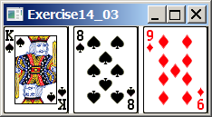

Your Task:
- Create three ImageView and set their icons using the images.
- Display three images from 54 image cards randomly.

Your Code:
package sample;

import javafx.application.Application;
import javafx.scene.Scene;
import javafx.stage.Stage;
import javafx.scene.image.ImageView;
import javafx.scene.image.Image;
import javafx.scene.layout.HBox;
import java.util.*;

public class Main extends Application {

@Override
public void start(Stage primaryStage) throws Exception{

//Array used to remove values and to ensure no duplicate cards are pulled
int[] intArray = new int[]{1,2,3,4,5,6,7,8,9,10,11,12,13,14,15,16,17,18,19,20,21,22,23,24,25,26,27,28,29,30,
31,32,33,34,35,36,37,38,39,40,41,42,43,44,45,46,47,48,49,50,51,52,53,54};

//Array used to store the values pulled randomly
int[] selectedCards = new int[3];
//Defines the cardNumber
int cardNumber = 0;

for (int i = 0; i <= 2; i++) {
boolean cond = false;

//Loops until the card pulled is distinct and unique
while(cond == false) {
cond = false;

//Pulls a random value from 0-53 which works for the array
int randVal = new Random().nextInt(54);
cardNumber = intArray[randVal];

//Loops for each selected card to check that the number pulled has not been pulled already
for (int j = 0; j < selectedCards.length; j++) {
//Checks if the card is already pulled
if (cardNumber == selectedCards[j]) {
cond = false;
break;
} else {
cond = true;
}
}

}
//Assigns the card pulled to the cards displayed
selectedCards[i] = cardNumber;
}

//Creates an Hbox
HBox hBox = new HBox(1);

//Pulls the card image from the cards folder and sets the width and height to fit the Hbox
ImageView card1 = new ImageView(new Image(getClass().getResourceAsStream("cards/" + String.valueOf(selectedCards[0]) + ".png")));
card1.setFitHeight(150);
card1.setFitWidth(100);

hBox.getChildren().add(card1);

//Pulls the card image from the cards folder and sets the width and height to fit the Hbox
ImageView card2 = new ImageView(new Image(getClass().getResourceAsStream("cards/" + String.valueOf(selectedCards[1]) + ".png")));
card2.setFitHeight(150);
card2.setFitWidth(100);

hBox.getChildren().add(card2);

//Pulls the card image from the cards folder and sets the width and height to fit the Hbox
ImageView card3 = new ImageView(new Image(getClass().getResourceAsStream("cards/" + String.valueOf(selectedCards[2]) + ".png")));
card3.setFitHeight(150);
card3.setFitWidth(100);

hBox.getChildren().add(card3);

//Creates a new scene and assigns the Hbox to it
Scene scene = new Scene(hBox,303,150);
primaryStage.setTitle("Question 1");
primaryStage.setScene(scene);
primaryStage.show();
}

public static void main(String[] args) {

launch(args);
}
}

Screen shots:
Include two screen shots here:

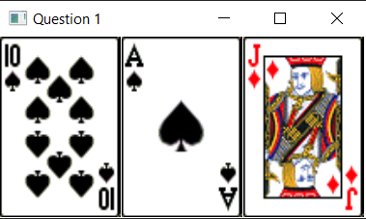

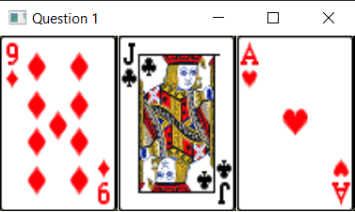

Question 2: Investment-Value calculator

Problem Description:
Write a program that calculates the future value of an investment at a given interest rate for a specified number of years. The formula for the calculation is as follows:

futureValue = investmentAmount * (1 + monthlyInterestRate)years*12

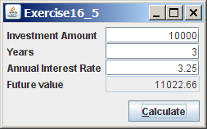

Your Task:
Use text fields for interest rate, investment amount, and years. Display the future amount in a text field when the user clicks the Calculate button, as shown in the figure.

Your Code:
package sample;
import javafx.application.Application;
import javafx.fxml.FXMLLoader;
import javafx.scene.Parent;
import javafx.scene.Scene;
import javafx.scene.control.*;
import javafx.stage.Stage;
import javafx.geometry.Pos;
import javafx.scene.layout.GridPane;
import java.lang.Math;
import java.text.DecimalFormat;
public class Main extends Application {
@Override
public void start(Stage primaryStage) throws Exception{
//creates and formats pane
GridPane pane = new GridPane();
pane.setVgap(5);
pane.setHgap(5);
pane.setAlignment(Pos.CENTER);
//creates fields for input and adds to pane
TextField amount = new TextField();
TextField years = new TextField();
TextField rate = new TextField();
pane.add(amount,1,0);
pane.add(years,1,1);
pane.add(rate,1,2);
//creates the TextFields labels and adds to pane
pane.add(new Label("Investment Amount:"),0,0);
pane.add(new Label("Years:"),0,1);
pane.add(new Label("Annual Interest Rate:"),0,2);
pane.add(new Label("Future Value:"),0,3);
pane.add(new Label(),1,3);
//add button
Button btn = new Button("Calculate");
pane.add(btn,1,4);
//Calculates on button press
btn.setOnAction(button -> {
//sets values
float total = Float.parseFloat(amount.getText());
float monthlyRate = Float.parseFloat(rate.getText())/100/12;
float exponent = Float.parseFloat(years.getText())*12;
double futureValue = total * (Math.pow(1+monthlyRate,exponent));
DecimalFormat df = new DecimalFormat("#.00"); //format to 2 decimals
pane.add(new Label(String.valueOf(df.format(futureValue))),1,3); //add equation to pane
});
//formats scene and shows
Scene scene = new Scene(pane,300,200);
primaryStage.setTitle("Question 2");
primaryStage.setScene(scene);
primaryStage.show();
}
public static void main(String[] args) { launch(args); }

Screen shots:
Include two screen shots here:

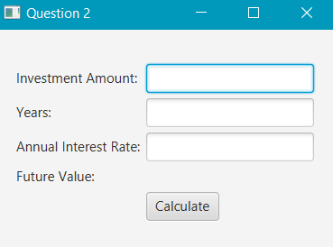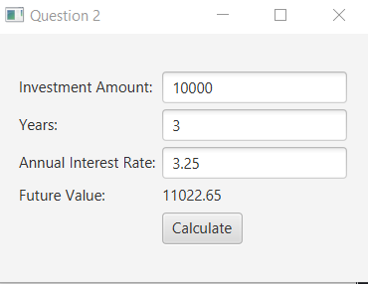

Question 3: Dragging Points on a Circle

Problem Description:
Draw a circle with three random points on the circle. Connect the points to form a triangle. Display the angles in the triangle. Use the mouse to drag a point along the perimeter of the circle. As you drag it, the triangle and angles are redisplayed dynamically.

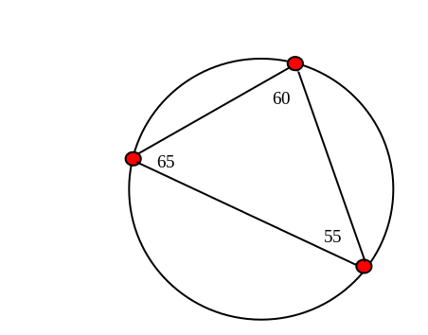

Here is the formula to compute angles:

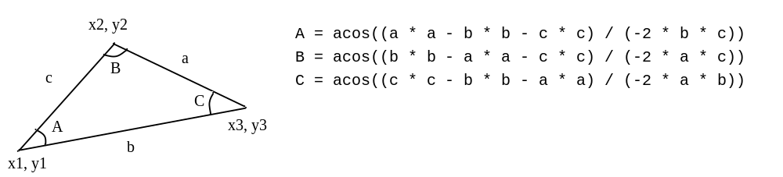

Your Code:
package sample;
import javafx.application.Application;
import javafx.geometry.Point2D;
import javafx.scene.Scene;
import javafx.scene.layout.Pane;
import javafx.scene.paint.Color;
import javafx.scene.shape.Circle;
import javafx.scene.shape.Line;
import javafx.scene.text.Text;
import javafx.stage.Stage;
public class Main extends Application {
//Definitions for variables and arrays used in the program
//Defines pointLine for the regenerateLine() function
public Line pointLine1 = new Line();
public Line pointLine2 = new Line();
public Line pointLine3 = new Line();
//Defines the radius for the circles that are dragged
public double radius = 8;
//Text fields for the angle output
public Text[] angleText = {new Text(), new Text(), new Text()};
//Creates the main circle that the interactive circles orbit
Circle circleMain = new Circle(200, 150, 80);
//Creates an array containing the interactive circles
public Circle[] circle = {new Circle(80 * Math.cos(200) + 200, 80 * Math.sin(200) + 150, 5),
new Circle(80 * Math.cos(140) + 200, 80 * Math.sin(140) + 150, 5),
new Circle(80 * Math.cos(300) + 200, 80 * Math.sin(300) + 150, 5)};
@Override // Override the start method in the Application class
public void start(Stage primaryStage) {
//Creates the main circles colours (Outline Black filled with white)
circleMain.setStroke(Color.BLACK);
circleMain.setFill(Color.WHITE);
for (int i = 0; i < circle.length; i++) {
//Creates the interactive circles colours (Outline Black filled with red)
circle[i].setStroke(Color.BLACK);
circle[i].setFill(Color.RED);
}
//Creates a pane to display the circles
Pane pane = new Pane();
//Sets the lines before any actual interaction
regenerateLines();
//Adds all parameters to the pane
pane.getChildren().addAll(circleMain, circle[0], circle[1], circle[2],
pointLine1, pointLine2, pointLine3, angleText[0], angleText[1], angleText[2]);
//Create a new scene and assign it to the primaryStage
Scene scene = new Scene(pane, 400, 250);
primaryStage.setTitle("Question 3");
primaryStage.setScene(scene);
primaryStage.show();
//Event Handlers for all 3 interactive circles
circle[0].setOnMouseDragged(e -> {
//Assigns everything as a Point2D vector to utilise the normalize() function
//The normalize() function creates the unit vector which we then multiply by the radius of the main circle
//Gets the cursor position
Point2D cursor = new Point2D(e.getX(), e.getY());
//Gets the center of the main circle
Point2D mainCenter = new Point2D(circleMain.getCenterX(), circleMain.getCenterY());
//gets the distance from mainCenter to the cursor
Point2D mainCenterToCursor = cursor.subtract(mainCenter);
//Gets the new position using the normal vector multiplied by the radius of circleMain
Point2D mainCenterToNewPosition = mainCenterToCursor.normalize().multiply(circleMain.getRadius());
//Gets the new value of the circle location
Point2D newPosition = mainCenterToNewPosition.add(mainCenter);
//Assigns the new position to the interactive circle
circle[0].setCenterX(newPosition.getX());
circle[0].setCenterY(newPosition.getY());
regenerateLines();
});
circle[1].setOnMouseDragged(e -> {
//Assigns everything as a Point2D vector to utilise the normalize() function
//The normalize() function creates the unit vector which we then multiply by the radius of the main circle
//Gets the cursor position
Point2D cursor = new Point2D(e.getX(), e.getY());
//Gets the center of the main circle
Point2D mainCenter = new Point2D(circleMain.getCenterX(), circleMain.getCenterY());
//gets the distance from mainCenter to the cursor
Point2D mainCenterToCursor = cursor.subtract(mainCenter);
//Gets the new position using the normal vector multiplied by the radius of circleMain
Point2D mainCenterToNewPosition = mainCenterToCursor.normalize().multiply(circleMain.getRadius());
//Gets the new value of the circle location
Point2D newPosition = mainCenterToNewPosition.add(mainCenter);
//Assigns the new position to the interactive circle
circle[1].setCenterX(newPosition.getX());
circle[1].setCenterY(newPosition.getY());
regenerateLines();
});
circle[2].setOnMouseDragged(e -> {
//Assigns everything as a Point2D vector to utilise the normalize() function
//The normalize() function creates the unit vector which we then multiply by the radius of the main circle
//Gets the cursor position
Point2D cursor = new Point2D(e.getX(), e.getY());
//Gets the center of the main circle
Point2D mainCenter = new Point2D(circleMain.getCenterX(), circleMain.getCenterY());
//gets the distance from mainCenter to the cursor
Point2D mainCenterToCursor = cursor.subtract(mainCenter);
//Gets the new position using the normal vector multiplied by the radius of circleMain
Point2D mainCenterToNewPosition = mainCenterToCursor.normalize().multiply(circleMain.getRadius());
//Gets the new value of the circle location
Point2D newPosition = mainCenterToNewPosition.add(mainCenter);
//Assigns the new position to the interactive circle
circle[2].setCenterX(newPosition.getX());
circle[2].setCenterY(newPosition.getY());
regenerateLines();
});
}
public void regenerateLines() {
//Displays the lines between the interactive circles
//Sets the line between circles 0,1 for line 1
pointLine1.setStartX(circle[0].getCenterX());
pointLine1.setStartY(circle[0].getCenterY());
pointLine1.setEndX(circle[1].getCenterX());
pointLine1.setEndY(circle[1].getCenterY());
//Sets the line between circles 0,2 for line 2
pointLine2.setStartX(circle[0].getCenterX());
pointLine2.setStartY(circle[0].getCenterY());
pointLine2.setEndX(circle[2].getCenterX());
pointLine2.setEndY(circle[2].getCenterY());
//Sets the line between circles 1,2 for line 3
pointLine3.setStartX(circle[1].getCenterX());
pointLine3.setStartY(circle[1].getCenterY());
pointLine3.setEndX(circle[2].getCenterX());
pointLine3.setEndY(circle[2].getCenterY());
//Calculates the angles for the triangle
//Assigns a Point2D to utilise the distance() function
double a = new Point2D(circle[2].getCenterX(), circle[2].getCenterY()).distance(circle[1].getCenterX(), circle[1].getCenterY());
double b = new Point2D(circle[2].getCenterX(), circle[2].getCenterY()).distance(circle[0].getCenterX(), circle[0].getCenterY());
double c = new Point2D(circle[1].getCenterX(), circle[1].getCenterY()).distance(circle[0].getCenterX(), circle[0].getCenterY());
//Creates an array to store the angle values
double[] angles = new double[3];
//Calculates the angle of each interactive circle
angles[0] = Math.acos((a * a - b * b - c * c) / (-2 * b * c));
angles[1] = Math.acos((b * b - a * a - c * c) / (-2 * a * c));
angles[2] = Math.acos((c * c - b * b - a * a) / (-2 * a * b));
for (int i = 0; i < 3; i++) {
//Outputs the text displaying the angle for each interactive circle
angleText[i].setX(circle[i].getCenterX());
angleText[i].setY(circle[i].getCenterY() - radius);
//Sets the text to a String (from double) and sets that text to the text value in the array
angleText[i].setText(String.format("%.2f", Math.toDegrees(angles[i])));
}
}
public static void main(String[] args) {
launch(args);
}
}

Screen shots:
Include two screen shots here:
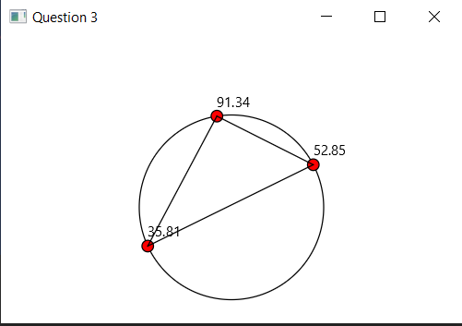
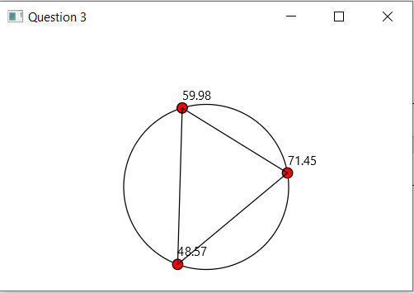

Question 4: Histogram

Problem Description:
Develop a program that displays a histogram to show the occurrences of each letter in a text area. The histogram should show the occurrences of each letter in a text file, as shown in the following figure. Assume that the letters are not case sensitive.

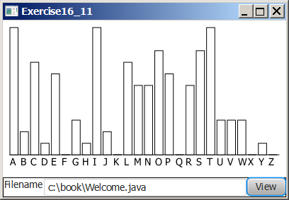

Your Task:
- Place a pane that will display the histogram in the center of the frame.
- Place a label and a text field in a panel, and put the panel in the south side of the frame. The text file will be entered from this text field.
- Pressing the Enter key on the text field causes the program to count the occurrences of each letter and display the count in a histogram.

Your Code:
package sample;
import javafx.application.Application;
import javafx.fxml.FXMLLoader;
import javafx.geometry.Pos;
import javafx.scene.Parent;
import javafx.scene.Scene;
import javafx.scene.input.KeyCode;
import javafx.scene.paint.Color;
import javafx.stage.Stage;
import javafx.scene.canvas.Canvas;
import javafx.scene.canvas.GraphicsContext;
import javafx.scene.layout.HBox;
import javafx.scene.layout.VBox;
import javafx.scene.control.TextField;
import javafx.scene.control.Label;
import javafx.scene.control.Button;
import org.w3c.dom.Text;
import java.util.Scanner;
import java.io.File;
public class Main extends Application {
String text = "";
int[] letters = new int[26];
@Override
public void start(Stage primaryStage) throws Exception{
Canvas canvas = new Canvas(350,100); //create canvas for BarChart
GraphicsContext gc = canvas.getGraphicsContext2D();
Label label = new Label(" A B C D E F G H I J K L M N O P Q R S T U V W X Y Z"); //BarChart label
TextField field = new TextField(); //file input space
Button btn = new Button("View"); //button to submit
//button parse through
btn.setOnAction(e -> { parseFile(gc,field); });
//parse through if enter button
field.setOnKeyPressed(e -> {
if (e.getCode() == KeyCode.ENTER) {
parseFile(gc,field);
}
});
VBox vbox = new VBox(2);
HBox hbox = new HBox(2);
//formats the UI
hbox.getChildren().addAll(field,btn);
vbox.getChildren().addAll(canvas,label,hbox);
vbox.setAlignment(Pos.BASELINE_LEFT); //sets vbox to the left
//Sets scene and show
Scene scene = new Scene(vbox,350,200);
primaryStage.setTitle("Question-4");
primaryStage.setScene(scene);
primaryStage.show();
}
//finds percentage of each letter in the file
private float[] getPercentage() {
float[] temp = new float[letters.length];
float total = 0f;
for (int i=0; i<letters.length; i++) { total += letters[i]; } //finds char total
for (int i=0; i<letters.length; i++) { temp[i] = (letters[i]/total)*100; } //finds percentage of each letter
return temp;
}
//Creates the chart using Canvas class
private void createChart(GraphicsContext gc) {
gc.setStroke(Color.BLACK);
gc.setLineWidth(10);
text = text.toLowerCase(); //Converts to lower case
for (int i=0; i<letters.length; i++) { letters[i] = 0; } //Setting letters to 0
for (int i=0; i<text.length(); i++) { letters[text.charAt(i)-97] += 1; } //Filling letters array
float[] percentage = getPercentage();
for (int i=0; i<letters.length; i++) {
int x = 10+i*11; //x value algorithm
gc.strokeLine(x,100,x,100-percentage[i]*2); //prints line
}
}
//Finds file text
private void parseFile(GraphicsContext gc, TextField field) {
File file = new File(field.getText());
//adds next line to text until file ends
try {
Scanner input = new Scanner(file);
while (input.hasNextLine()) {
text += input.next();
}
createChart(gc);
}
catch(Exception e1){ System.out.println("File DNE"); } //file doesn't exist
}
public static void main(String[] args) { launch(args); }
}

Screen shots:
Include two screen shots here:
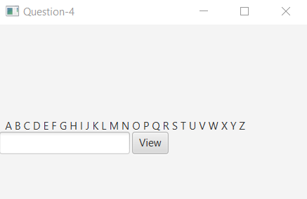
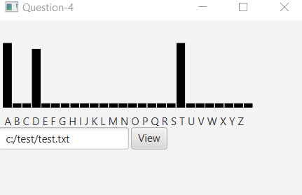

Remember:

You need to complete this file and submit it in related drop box on Blackboard, in addition to uploading your codes in your git repository, before deadline.

